Equity Graphics
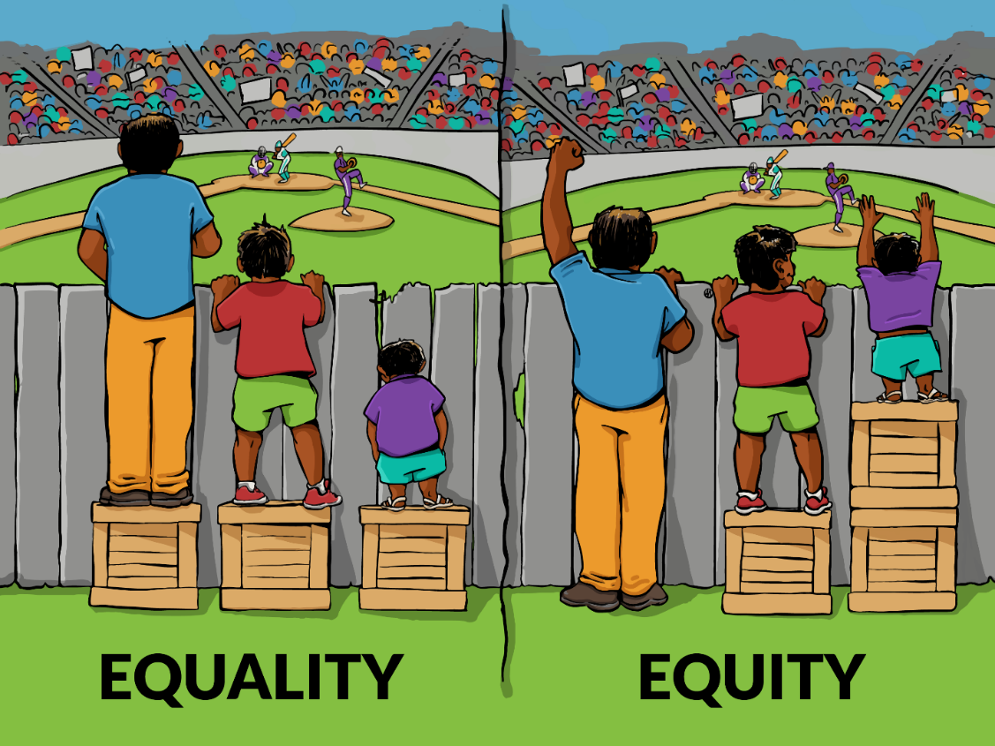

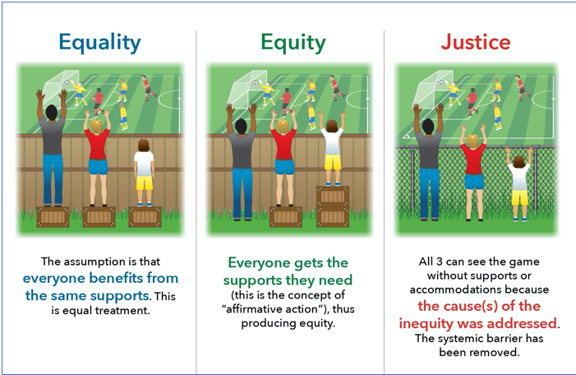

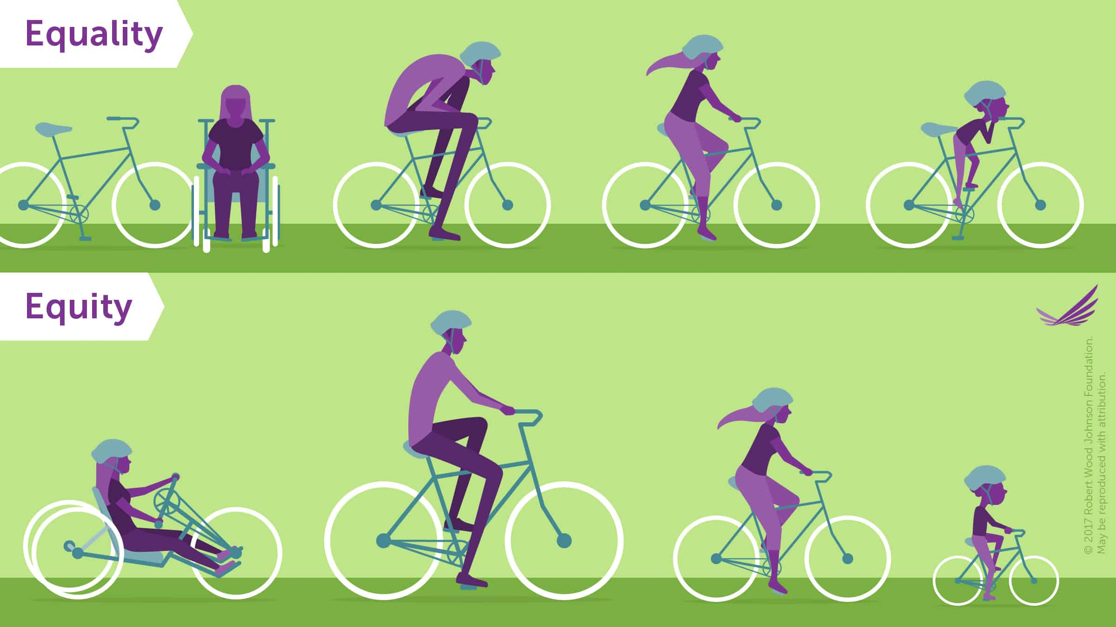

HEALTH EQUITY: the absence of unfair and avoidable or remediable differences in health among population groups defined socially, economically, demographically or geographically - World Health Organization
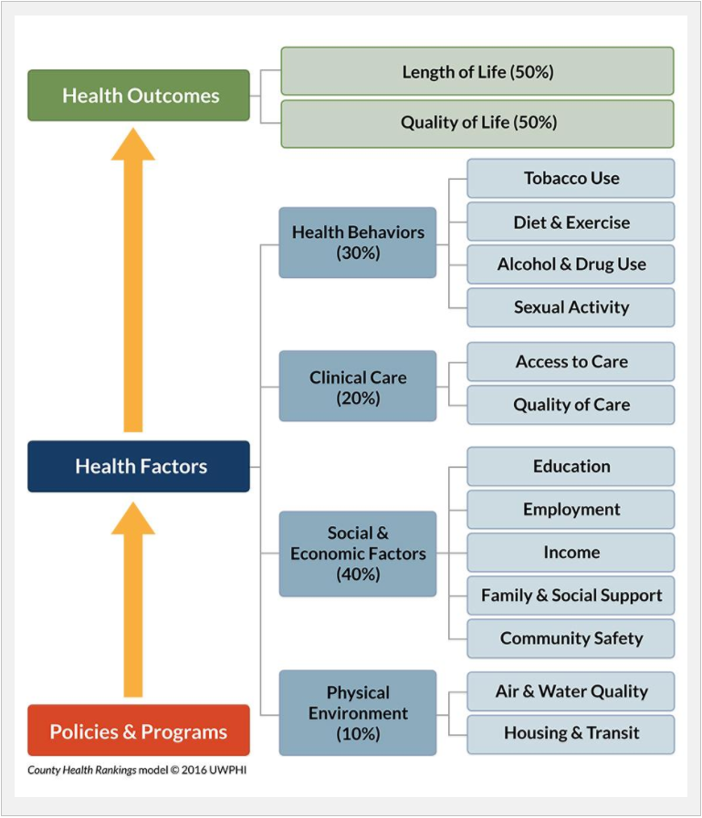
UW-Madison Population Health Institute © 2016

