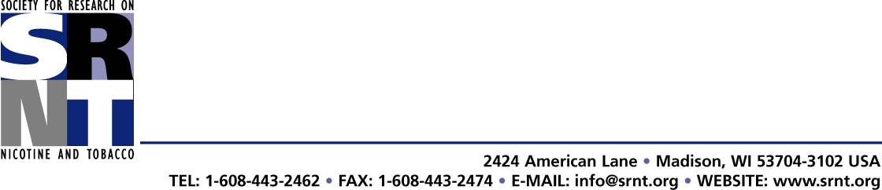

November 2, 2015

Dear APA Commission for the Recognition of Specialties and Proficiencies,

I write to express support for the renewal petition for an APA-approved proficiency in the Psychological Treatment of Alcohol and Other Psychoactive Substance Use Disorders that has been submitted by APA Divisions 50 and 28. The Society for Research on Nicotine and Tobacco (SRNT) is a member-based organization focused on stimulating the generation of new knowledge concerning nicotine in all its manifestations - from molecular to societal, and on encouraging scientific research on public health efforts for the prevention and treatment of tobacco use. Several of the leaders and members of the Divisions 50 and 28 are also members of our organization. Our mission overlaps substantially with the missions of both Division 50 and 28, and we fully support their continued effort to define and administer this important Proficiency for psychologists. This Proficiency and the related Certification process that designates individual psychologists as trained and prepared to provide expert interventions for substance use disorders is responsive to a major public health need. We support the Proficiency as it has been described in the application, and the educational and training activities of SRNT help support the training of psychologists who seek to obtain the Proficiency.

Sincerely,
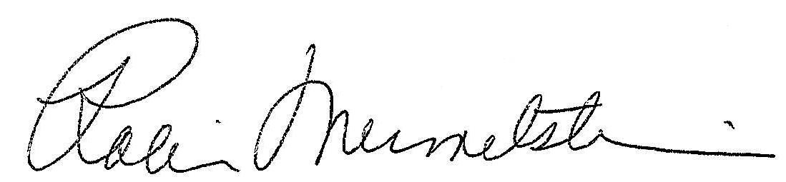

Robin Mermelstein, Ph.D.
President, Society for Research on Nicotine and Tobacco

