[Updated: SRNT Position on Changes to the US Healthcare Rights Law]

Dear SRNT members,
On June 12, 2020 we learned that the US Department of Health and Human Services (HHS) finalized a ruling to remove nondiscrimination protections for lesbian, gay, bisexual, transgender, and queer/questioning (LGBTQ) individuals under Section 1557 of the Affordable Care Act. The timing of this ruling in the midst of the COVID-19 pandemic will adversely impact the health, well-being, and lives of millions of LGBTQ patients who are at increased risk of being affected by COVID-19. Thus, we are re-issuing the statement from the SRNT Board of Directors (July 9, 2019) to reiterate SRNT’s strong opposition against this ruling and support for all LGBTQ members of our community. In addition, we have provided potential resources for how you can help.
The landmark Section 1557 of the Affordable Care Act specifically prohibits discrimination on the basis of sex in health care settings and when obtaining health insurance. In 2016, HHS promulgated regulations interpreting the protections in Section 1557 to include protections against discrimination on the basis of gender identity and sexual orientation. The new HHS regulation reverses these extremely important nondiscrimination protections for LGBTQ individuals by removing sexual orientation and gender identity nondiscrimination language from rules governing the health insurance exchanges, Qualified Health Plans, Medicaid, and other covered entities. This is especially troubling because the LGBTQ community is less likely to have health insurance, and experiences barriers to healthcare access because of discrimination and bias in health care settings.[1]
On top of those disparities, through the work of many of our society members and community partners, we know that cigarette smoking and other forms of commercial tobacco use disproportionately affect the health of LGBTQ individuals. Lesbians and bisexual women’s rates of cigarette smoking are, respectively, 3 to 5 times higher than those of heterosexual women. Gay men smoke cigarettes at twice the rate of heterosexual men. Transgender adults smoke cigarettes at twice the rate of cisgender adults.[2] [3] A primary driver of this health disparity is the industry’s abhorrent targeting of the LGBTQ community, referred to as “Project SCUM” (subculture urban marketing), that preyed on the LGBTQ’s community’s desire to feel pride and belonging.[4]
Because of these disparities, access to healthcare and health insurance can be pivotal in successful cessation of commercial tobacco use. The Affordable Care Act was instrumental in expanding access to tobacco cessation treatment and helping vulnerable populations quit smoking.[5] Thus, the finalized ruling by the HHS would likely contribute to widening tobacco-related health disparities among the LGBTQ community.
Furthermore, the lack of access to culturally appropriate and supportive health care and treatment is likely to increase tobacco use among LGBTQ people because research demonstrates that commercial tobacco use is closely related to an individual's environment and their experiences regarding the social determinants of health. The LGBTQ community encounters sexual orientation and gender minority stigma, healthcare discrimination, and stress at the individual, interpersonal, community, and policy levels. These realities contribute to their increased commercial tobacco use.[6] [7] Removing protections for the LGBTQ community threatens progress towards a world free of the harms created by the tobacco industry.
SRNT’s shared values are respect for the worth and dignity of individuals, inclusiveness and social justice, respect for pluralism and diversity, and respect for all persons, regardless of race, religion, gender, sexual orientation, abilities, age or national origin. SRNT believes that the finalized HHS regulations to roll back the provisions in Section 1557 are inconsistent with the Society’s core mission and shared values, and will widen tobacco-related health disparities among vulnerable populations including LGBTQ individuals.
We understand that many of us may be hurt, upset, concerned, and alarmed by the finalized HHS regulations. SRNT is dedicated to providing a safe, inclusive, respectful and supportive environment for all LGBTQ members of our community. We do not condone any form of discrimination. We are committed to serving the public good, the best interests of our members, and the profession at large. This goal can only be achieved by fostering an environment that is based on fair, equal, and just treatment for all.
How You Can Help:
(1) Arrange an LGBTQ+ cultural competency training at your organization (e.g., National LGBTQ Cancer Network has a good one, with some excellent materials focusing specifically on transgender individuals), (2) Include LGBTQ+-specific resources in your treatment/resource materials (e.g., if working with young people, list Trevor Project along with other crisis support info),
(3) Ask about sexual orientation and gender identity on your study surveys in an affirming way, consistent with current best practices,
(4) Include images, stories, and other representations of LGBTQ+ people in study advertising, treatment materials, resource guides, websites, and others (e.g., from Broadly’s Gender Spectrum Collection photo library)
(5) Add language to your research group’s web page, social media, etc. explicitly indicating your commitment to diversity, inclusion, and equity, including the LGBTQ+ community.

If you have any questions or concerns, we encourage you to reach out to the following helpful resources in this link which will be updated regularly: https://bit.ly/3d7RDfv
Sincerely,
Health Disparities Network
SRNT Board of Directors
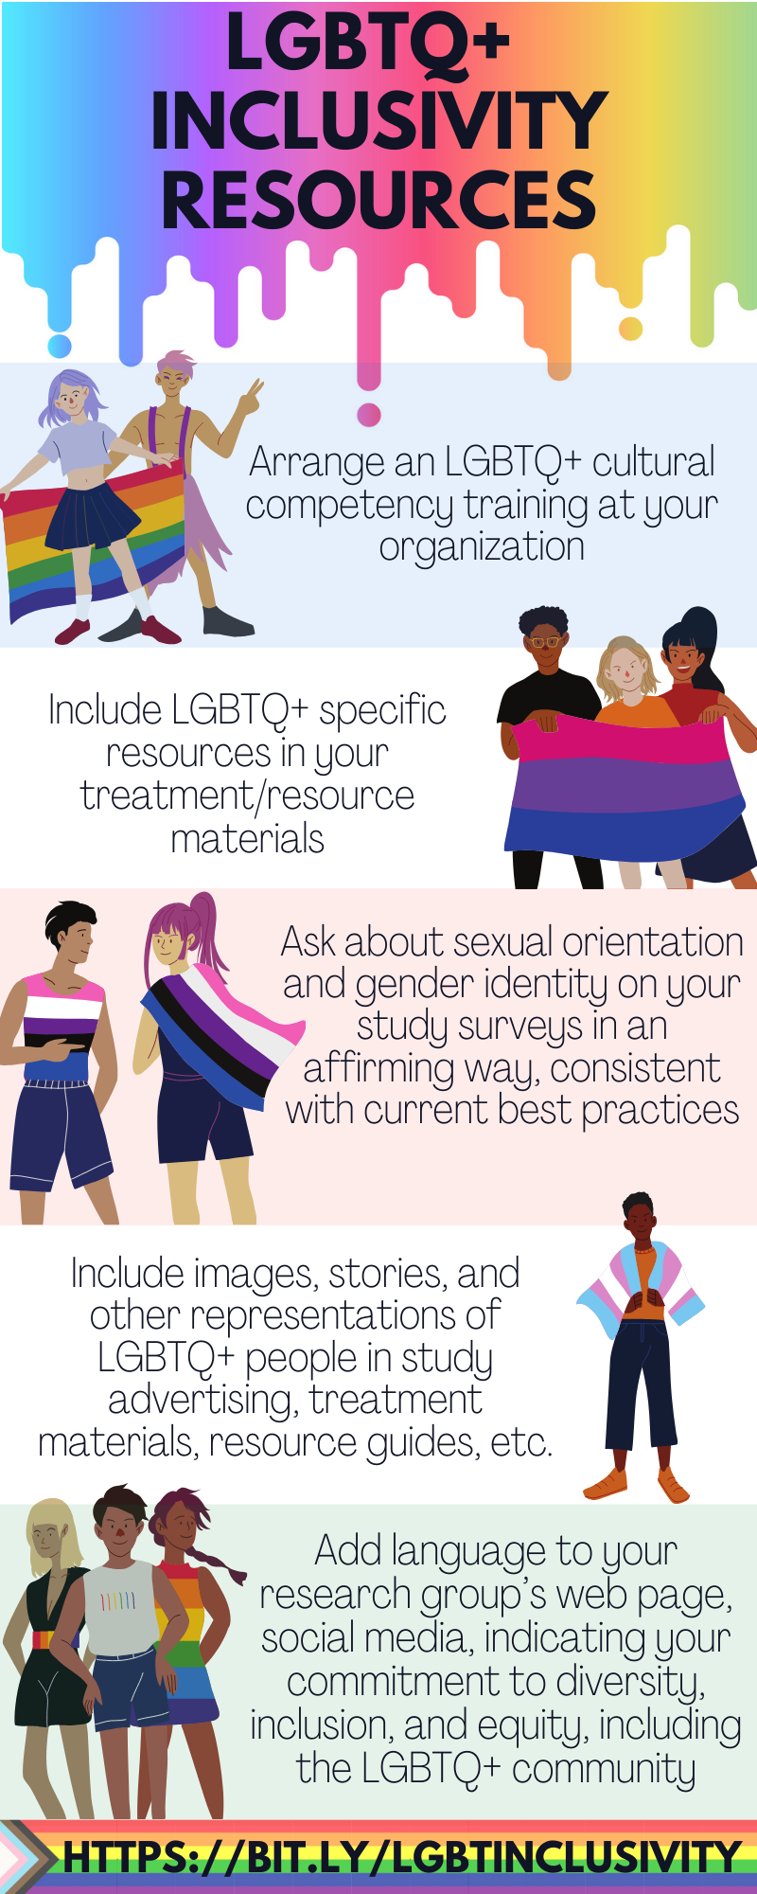
[1] Quinn GP, Sutton SK, Winfield B, et al. Lesbian, Gay, Bisexual, Transgender, Queer/Questioning (LGBTQ) Perceptions and Health Care Experiences. J Gay Lesbian Soc Serv. 2015;27(2):246-261.
[2] Buchting FO, Emory KT, Scout, et al. Transgender use of cigarettes, cigars, and e-cigarettes in a national study. Am J Prev Med. 2017;53:e1–e7.
[3] Wheldon CW, Kaufman AR, Kasza KA, Moser RP. Tobacco Use Among Adults by Sexual Orientation: Findings from the Population Assessment of Tobacco and Health Study. LGBT Health. 2018;5(1):33-44.
[4] Stevens, P., Carlson, L. M., & Hinman, J. M. (2004). An analysis of tobacco industry marketing to lesbian, gay, bisexual, and transgender (LGBT) populations: strategies for mainstream tobacco control and prevention. Health Promotion Practice, 5(3 suppl), 129S-134S.
[5] Bailey SR, Marino M, Ezekiel-Herrera D, et al. Tobacco Cessation in Affordable Care Act Medicaid Expansion States versus Non-Expansion States. Nicotine Tob Res. May 2019 (In press, online). doi:10.1093/ntr/ntz087
[6] Pachankis JE, Hatzenbuehler ML, Starks TJ. The influence of structural stigma and rejection sensitivity on young sexual minority men’s daily tobacco and alcohol use. Social Science & Medicine. 2014;103:67-75.
[7] Hatzenbuehler ML, Jun H-J, Corliss HL, Austin SB. Structural stigma and cigarette smoking in a prospective cohort study of sexual minority and heterosexual youth. Ann Behav Med. 2014;47(1):48-56.

